CS 499 Module One Assignment Template

Complete this template by replacing the bracketed text with the relevant information.

- Self-Introduction: Address all of the following questions to introduce yourself.

  - How long have you been in the Computer Science program?

I have been enrolled in the computer science program at Southern New Hampshire University for almost two and a half years.

  - What have you learned while in the program? List three of the most important concepts or skills you have learned.

Three of the most important concepts or skills I have learned are:
        - Database design and data management, CRUD operations, data validation, and indexing
        - Software design, the software development lifecycle, abstraction, and encapsulation.
        - Algorithms and data structures, how to selecte correct data strcutrers to solve real world problems and serve real world applications.
  - Discuss the specific skills you aim to demonstrate through your enhancements to reach each of the course outcomes.

Through my enhancements I will demonstrate collaboration and communication skills by imoproving code structures, and application useage and functionality. I will demonstrate algorthimic problem solving skills by enhancing data processing in the application and the application analysis features. Finally, I will demostarte a secrutiy mindset by identifying peterntial vulnerabilities and implemeneint best practices for data validation and access controls.
  - How do the specific skills you will demonstrate align with your career plans related to your degree?

I have a very unique carrer plan forward, I am already a business owner owning a property inspection and radon mitigation business with multiple employees. So my goal for this degree is to use it to implement applications in my field in order to better serve customers and to open a new market for inspection software and radon mitigation tools. I will use the skills demonstrated to help me build the confidence and knowledge necessary to build another business in the application design and development space.

  - How does this contribute to the specialization you are targeting for your career?

The specialization I am targeting in my carerr is application development so my plan to use my previous code from my health tracker application will contribute to my specilazation by adding more knowledge and familiarity to coding applications.

- ePortfolio Set Up:

  - Submit a screen capture of your ePortfolio GitHub Pages home page that clearly shows your URL.
    - You already have a repository in GitHub where you uploaded projects in previous courses. Your ePortfolio will reside in GitHub but can link to work at other sites, such as Bitbucket.

  - Use the GitHub Pages link in the Resource section for directions on:
    - How to create your GitHub website and publish code to GitHub Pages
    - Issues, such as adding links to other sites

  - Paste a screenshot of your GitHub Pages home page with your URL clearly showing in the space below.

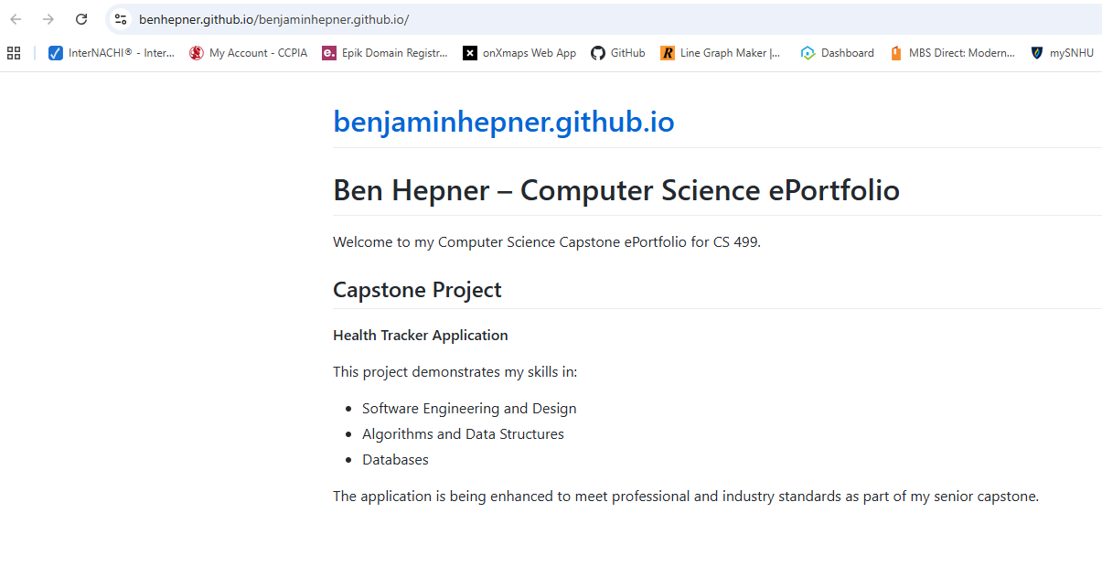

- Enhancement Plan:

  - Category One: Software Engineering and Design
    - Select an artifact that is aligned with the software engineering and design category and explain its origin. Submit a file containing the code for the artifact you choose with your enhancement plan.

The artifact I have selected for this category is my Helath Tracker application, I developed this application originally as apart of the course work within my program. This application was created to allow users to enter and manage weight tracking data.

Note: Your artifact may be work from the following courses:

- IT 145: Foundation in Application Development
- CS 250: Software Development Lifecycle
- CS 260: Data Structures and Algorithms
- IT 315: Object Oriented Analysis and Design
- CS 320: Software Testing, Automation, and Quality Assurance
- CS 330: Computational Graphics and Visualization
- CS 340: Advanced Programming Concepts
- CS 350: Emerging Systems Architectures and Technologies
- CS 360: Mobile Architecture and Programming
- IT 365: Operating Environments
- IT 380: Cybersecurity and Information Assurance
- CS 405: Secure Coding
- CS 410: Reverse Software engineering
- IT 340: Network and Telecommunication Management
- IT 380: Cybersecurity and Information Assurance

    - Describe a practical, well-illustrated plan for enhancement in alignment with the category, including a pseudocode or flowchart that illustrates the planned enhancement.

I plan on enhancing my Health Tracker application by improving overall software design and architecture. This includes major refactoring of the application to separate concerns between the user interface, business logic, and data access layers. Additionally, I will improve the error handling, logging, and expanded the documentation to support collaboration.
Pseudocode:
User submits health data
- Validate input
- Pass rewuet to service layer
- Service layer applies business fules
- Data access layer persists data
- Log operation
- Return response to user

For this category of enhancement, consider improving a piece of software, transferring a project into a different language, reverse engineering a piece of software for a different operating system, or expanding a project’s complexity. These are just recommendations. Consider being creative and proposing an alternative enhancement to your instructor.

Think about what additions to include to complete the enhancement criteria in this category. Since one example option is to port to a new language, that is the kind of scale that is expected. This does not mean you need to port to a new language but instead have an equivalent scale of enhancement. Underlying expectations of any enhancement include fixing errors, debugging, and cleaning up comments, but these are not enhancements themselves.

    - Explain how the planned enhancement will demonstrate specific skills and align with course outcomes.

      - Identify and describe the specific skills you will demonstrate that align with the course outcome.

Software architecture and modular design
Code refactoring and maintainablitiy
Documentation and collaboration practices
Secure handling of user input and data

      - Select one or more of the course outcomes below that your enhancement will align with.

Outcome 1, 2, 4, 5
Course Outcomes:

- Employ strategies for building collaborative environments that enable diverse audiences to support organizational decision-making in the field of computer science.
- Design, develop, and deliver professional-quality oral, written, and visual communications that are coherent, technically sound, and appropriately adapted to specific audiences and contexts.
- Design and evaluate computing solutions that solve a given problem using algorithmic principles and computer science practices and standards appropriate to its solution while managing the trade-offs involved in design choices.
- Demonstrate an ability to use well-founded and innovative techniques, skills, and tools in computing practices for the purpose of implementing computer solutions that deliver value and accomplish industry-specific goals.
- Develop a security mindset that anticipates adversarial exploits in software architecture and designs to expose potential vulnerabilities, mitigate design flaws, and ensure privacy and enhanced security of data and resources.

  - Category Two: Algorithms and Data Structures

- Select an artifact that is aligned with the algorithms and data structures category and explain its origin. Submit a file containing the code for the artifact you choose with your enhancement plan. You may choose work from the courses listed under Category One.

I will also use my Health Tracker Application for this acategory. The application processes time series health data, making it well suited for enhancement using algorithmis techniques.

- Describe a practical, well-illustrated plan for enhancement in alignment with the category, including a pseudocode or flowchart that illustrates the planned enhancement.
I plan to enhance the application by implementing algorthimis analysis of the health data, sucah as calculating trends, averages, and changes over time. This will require selecting appropriate data structures and algorthims to efficiently process historical records.

Pseudocode
Retrieve user health record
-Sort records by date
-Iterate through records
-Calcualate rolling average
-Detect significant changes
-Store or display results

For this category of enhancement, consider improving the efficiency of a project or expanding the complexity of the use of data structures and algorithms for your artifact. These are just recommendations. Consider being creative and proposing an alternative enhancement to your instructor. Note: You only need to choose one type of enhancement per category.

Think about what additions to include to complete the enhancement criteria in this category. Since one example option is to port to a new language, that is the kind of scale that is expected. Perhaps you might increase the efficiency and time complexity of an algorithm in an application and detail the logic of the increased time complexity. Remember, you do not need to port to a new language but instead have an equivalent scale of enhancement. Underlying expectations of any enhancement include fixing errors, debugging, and cleaning up comments, but these are not enhancements themselves.

- Explain how the planned enhancement will demonstrate specific skills and align with course outcomes.

  - Identify and describe the specific skills you will demonstrate to align with the course outcome.

Algorthim design evaluation
Data structure selection
Problem solving using computer science principles

  - Select one or more of the course outcomes listed under Category One that your enhancement will align with.

Outcome 3, 4
  - Category Three: Databases

    - Select an artifact that is aligned with the databases category and explain its origin. Submit a file containing the code for the artifact you choose with your enhancement plan. You may choose work from the courses listed under Category One.

I will also use my Health Tracker application for this category as it includes a database component used to store user enter health data.

    - Describe a practical, well-illustrated plan for enhancement in alignment with the category, including a pseudocode or flowchart that illustrates the planned enhancement.

I plan to enhance the database design by rfining the schema, adding calidation rules, and improving the query performance through indexing. I will also incorporate a security focused enhancements sucha s access controls to protect sentative user data.
Pseudocode
Receive database request
-Authenticate user
-Validate data fields
-Apply database constraints
-Execute optimized query
-Return results
For this category of enhancement, consider adding more advanced concepts of MySQL, incorporating data mining, creating a MongoDB interface with HTML/JavaScript, or building a full stack with a different programming language for your artifact. These are just recommendations; consider being creative and proposing an alternative enhancement to your instructor. Note: You only need to choose one type of enhancement per category.

Think about what additions to include to complete the enhancement criteria in this category. Since one example option is to port to a new language, that is the kind of scale that is expected. Perhaps you might increase the efficiency and time complexity of an algorithm in an application and detail the logic of the increased time complexity. Remember, you do not need to port to a new language but instead have an equivalent scale of enhancement. Underlying expectations of any enhancement include fixing errors, debugging, and cleaning up comments, but these are not enhancements themselves.
    - Explain how the planned enhancement will demonstrate specific skills and align with course outcomes.

      - Identify and describe the specific skills you will demonstrate that align with the course outcome.

Database schema design and optimization
Data Validation and integrity
Secure data access practices

      - Select one or more of the course outcomes listed under Category One that your enhancement will align with.

Outcomes 4, 5
- ePortfolio Overall Skill Set

  - Accurately describe the skill set to be illustrated by the ePortfolio overall.
    - Skills and outcomes planned to be illustrated in the code review

In the code review I will demonstrate software design decisions, algorthimic reasoning, databae usage, and security consideration. This will align with the outcomes 3, 4 and 5.

    - Skills and outcomes planned to be illustrated in the narratives

In the written narratives I will demostarte professional communication, collaboration strategies. This will align with the outcomes 1 and 2.

    - Skills and outcomes planned to be illustrated in the professional self-assessment

The professional self-assessment will reflect my growth as a software developer, lessons I have learned, and alignment with my career goals. This will support and align with all five of the course outcomes.

